SOFTWARE ENGINEERING & WEB DEVELOPMENT LAB MANUAL
PROJECT CASE STUDY: LEDGERLY — INVOICE & QUOTATION GENERATOR PWA

Experiment No. 1: Project Selection and Conceptualization

1. Pre-Requisites
• Basic knowledge of the Software Development Life Cycle (SDLC) & Agile principles.
• Understanding of small business accounting, billing lifecycles, and user needs.
• Fundamentals of requirement gathering and stakeholder boundary definition.
• Awareness of modern web standards, browser persistence, and offline web apps.

2. Problem Statement
Freelancers, consultants, contractors, and small-to-medium enterprise (SME) owners frequently struggle with creating, tracking, and maintaining professional invoices. Currently, billing is often handled manually through error-prone spreadsheet templates, generic Word documents, or bulky subscription-based accounting software that requires mandatory internet connectivity and complex setups.
This leads to severe operational bottlenecks: calculation mistakes in tax and discount rates, inconsistent invoice numbering, lack of audit trails for partial payment settlements, missing client directories, and delays in payment collection.
The goal is to design and develop 'Ledgerly' — a high-performance, offline-first Progressive Web Application (PWA) Invoice and Quotation Management System. Ledgerly allows users to swiftly compile professional invoices and estimates, automatically calculate multi-tier taxes (CGST/SGST/IGST), collect digital signatures on canvas, generate instant UPI payment QR codes, track partial payment ledgers, and export print-ready PDFs directly in the browser without third-party server lock-in.

3. Theory

3.1 Project Conceptualization
Project conceptualization involves identifying core user pain points, establishing system boundaries, determining key user personas, and specifying architectural feasibility. Key elements include:
• Project Scope – Defining clear functional boundaries (In-Scope vs. Out-of-Scope).
• Stakeholder & Actor Identification – Identifying who creates, approves, and receives invoices.
• Core Functional Modules – Grouping operations into cohesive functional subsystems.
• Feasibility Analysis – Assessing technical, operational, and financial feasibility.

3.2 Need for a Client-Side Modern Invoicing Engine
Traditional desktop and cloud ERP systems have several disadvantages for micro-enterprises:
• High monthly recurring subscription costs.
• Rigid templates with limited on-device custom styling.
• Dependency on uninterrupted cloud internet connectivity.
• Privacy risks when uploading sensitive financial and customer contact data to third-party databases.
An offline-first, client-rendered web application guarantees immediate availability, zero subscription cost, and total data privacy.

4. Project Scope

4.1 In-Scope Functionalities
1. Enterprise Profile Management: Configure company name, GSTIN, address, logo, bank details, and UPI ID.
2. Customer Directory: Maintain client records with GSTIN, email, phone, and billing address.
3. Dynamic Line-Item Builder: Real-time item rows with HSN codes, quantity, unit price, and itemized tax rates.
4. Automated Calculation Engine: Instant computation of subtotal, flat/percentage discounts, intra/inter-state GST, additional charges, and integer round-off.
5. Canvas Digital Signature: Native HTML5 canvas capture for handwritten signatures.
6. Dynamic UPI QR Code: On-the-fly payment QR generation using UPI deep-links.
7. Payment Settlement Ledger: Record multiple installment payments (Cash, UPI, NEFT, Card) and compute remaining balance due.
8. Multi-Template PDF & Print Export: 4 design presets (Classic, Modern Teal, Minimal, Compact) with lossless browser print and direct PDF download.
9. Offline-First PWA: Service worker asset caching and local browser storage persistence.

4.2 Out-of-Scope (Future Enhancements)
• Direct bank-to-bank automated reconciliation API.
• Multi-tenant centralized cloud database sync.
• Native mobile app binary deployment (App Store / Play Store).

5. Stakeholders & User Roles
Stakeholder / Role | Description | Primary System Needs
Freelancer / Contractor | Independent professional billing clients for hours or milestones. | Fast quotation creation, UPI payment QR, PDF downloads.
Small Business Owner / Retailer | Commercial store or service enterprise owner. | GST compliance (CGST/SGST/IGST), customer directory, partial payment tracking.
Accountant / Auditor | Reviews financial balance and records. | Receivables aging, payment settlement history, CSV/JSON data backup.
Client / Buyer | Recipient of invoice or estimate. | Clear itemized charges, accurate tax breakdown, clickable payment link/QR.

6. Core Modules of the System
Module Name | Primary Responsibilities
Authentication & Session Guard | User signup, credential verification, session retention in localStorage, and protected route guarding.
Enterprise Profile Module | Manage multiple business profiles, default tax rates, bank credentials, and base64 company logos.
Customer Management Module | Store client contact records, billing addresses, tax IDs, and transaction histories.
Invoice & Estimate Builder | Dynamic line-item manipulation, item catalog autofill, discount engine, and canvas signature pad.
Calculation & Tax Engine | Compute subtotals, intra-state (CGST 9% + SGST 9%) vs inter-state (IGST 18%) tax splits, extra shipping/handling, and auto round-off.
Payment & Settlement Ledger | Maintain chronological payment installments, adjust remaining balance dues, and toggle invoice states (Unpaid, Partially Paid, Paid).
Export & Dispatch Module | Client-side PDF generation via html2pdf.js, standard A4 thermal/sheet printing, and one-click WhatsApp/Email dispatch.
Dashboard & Analytics | Financial KPI cards (Total Billed, Collected, Balance Due, Overdue Count), receivables aging, and 6-month revenue SVG charts.

7. Assumptions & Constraints
Assumptions:
• Users access the application via a modern ECMAScript 6+ compatible web browser (Chrome, Edge, Firefox, Safari).
• The client machine supports localStorage with at least 5MB quota available.
Constraints:
• Offline persistence is scoped to the local browser profile unless the user exports data backups.
• Real-time payment verification depends on external payment gateways or manual merchant acknowledgement.

8. Feasibility Analysis
• Technical Feasibility: Built entirely using standard HTML5, CSS3, Vanilla JavaScript, and Service Workers. Requires zero proprietary server dependencies.
• Operational Feasibility: Extremely intuitive Single-Page Application (SPA) with zero installation hurdles. Runs instantly from file or web host.
• Economic Feasibility: 100% open-source development stack with zero software licensing or recurring database server hosting expenses.

9. High-Level Concept Map

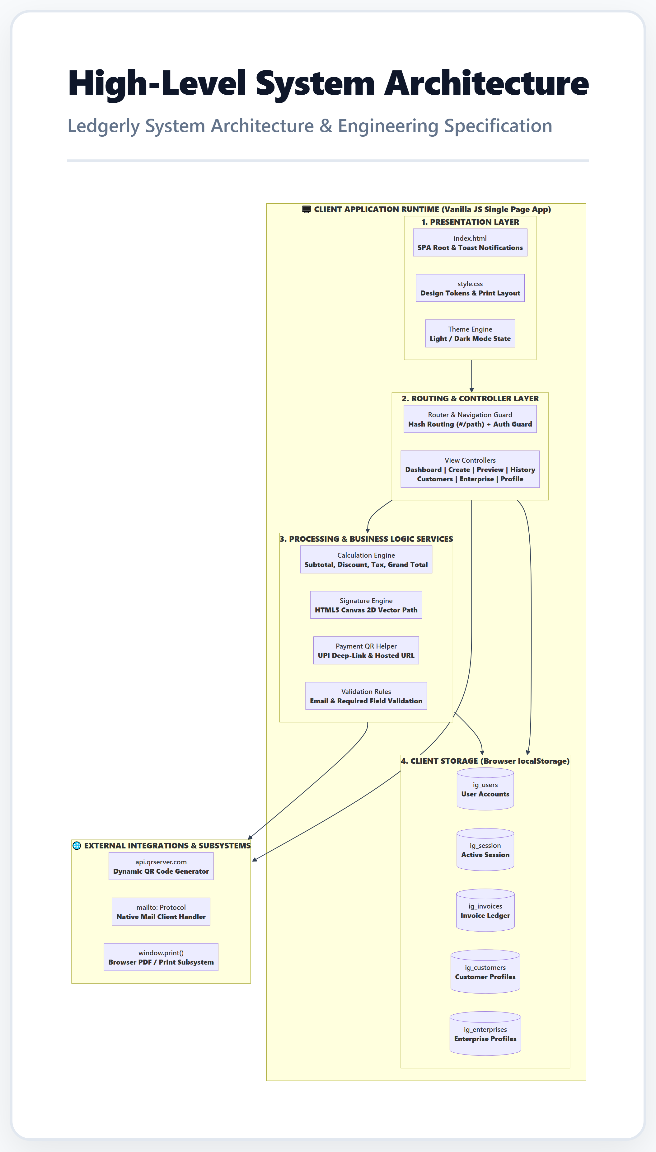
Figure: Ledgerly High-Level System Architecture and Runtime Blueprint

10. Conclusion
The project 'Ledgerly (Invoice & Quotation Generator)' was successfully conceptualized with an exhaustive problem definition, well-bounded scope, distinct stakeholder profiles, structured functional modules, and thorough feasibility validation. This robust foundation establishes the operational framework for subsequent software engineering phases including requirements modeling, UI architecture, UML diagrams, automated testing, and deployment.

